swarmathon 4

advanced deterministic search (BFS)

# spiral search

In Swarmathon 1 and 2, we examined biologically-inspired search techniques that employed randomness. In Swarmathon 3, we examined a type of deterministic search called Depth-First Search (DFS). In Swarmathon 4, the final module before you begin your competition submission, we will explore another type of deterministic search called Breadth-First Search (BFS). We will also create a *heterogenous* swarm in which robots can have different behaviors.

## what is BFS?

Stigmergy is communication that occurs through the environment, getting started

## file setup

As in Swarmathon 1 -3, we will be using Netlogo base code. Create a folder called *yourlastname_Swarmathon4.nlogo .* Place the file *[Sw4]AdvDetSearchstudentCode.nlogo* and the *parkingLot.jpg* picture in the folder.

# circling towards success

## what do we need to add?

To implement spiral search in the robots, we’ll need to code the following behaviors:

main agenda

1. Robots need to know

Let’s begin by tackling agenda items.

agenda

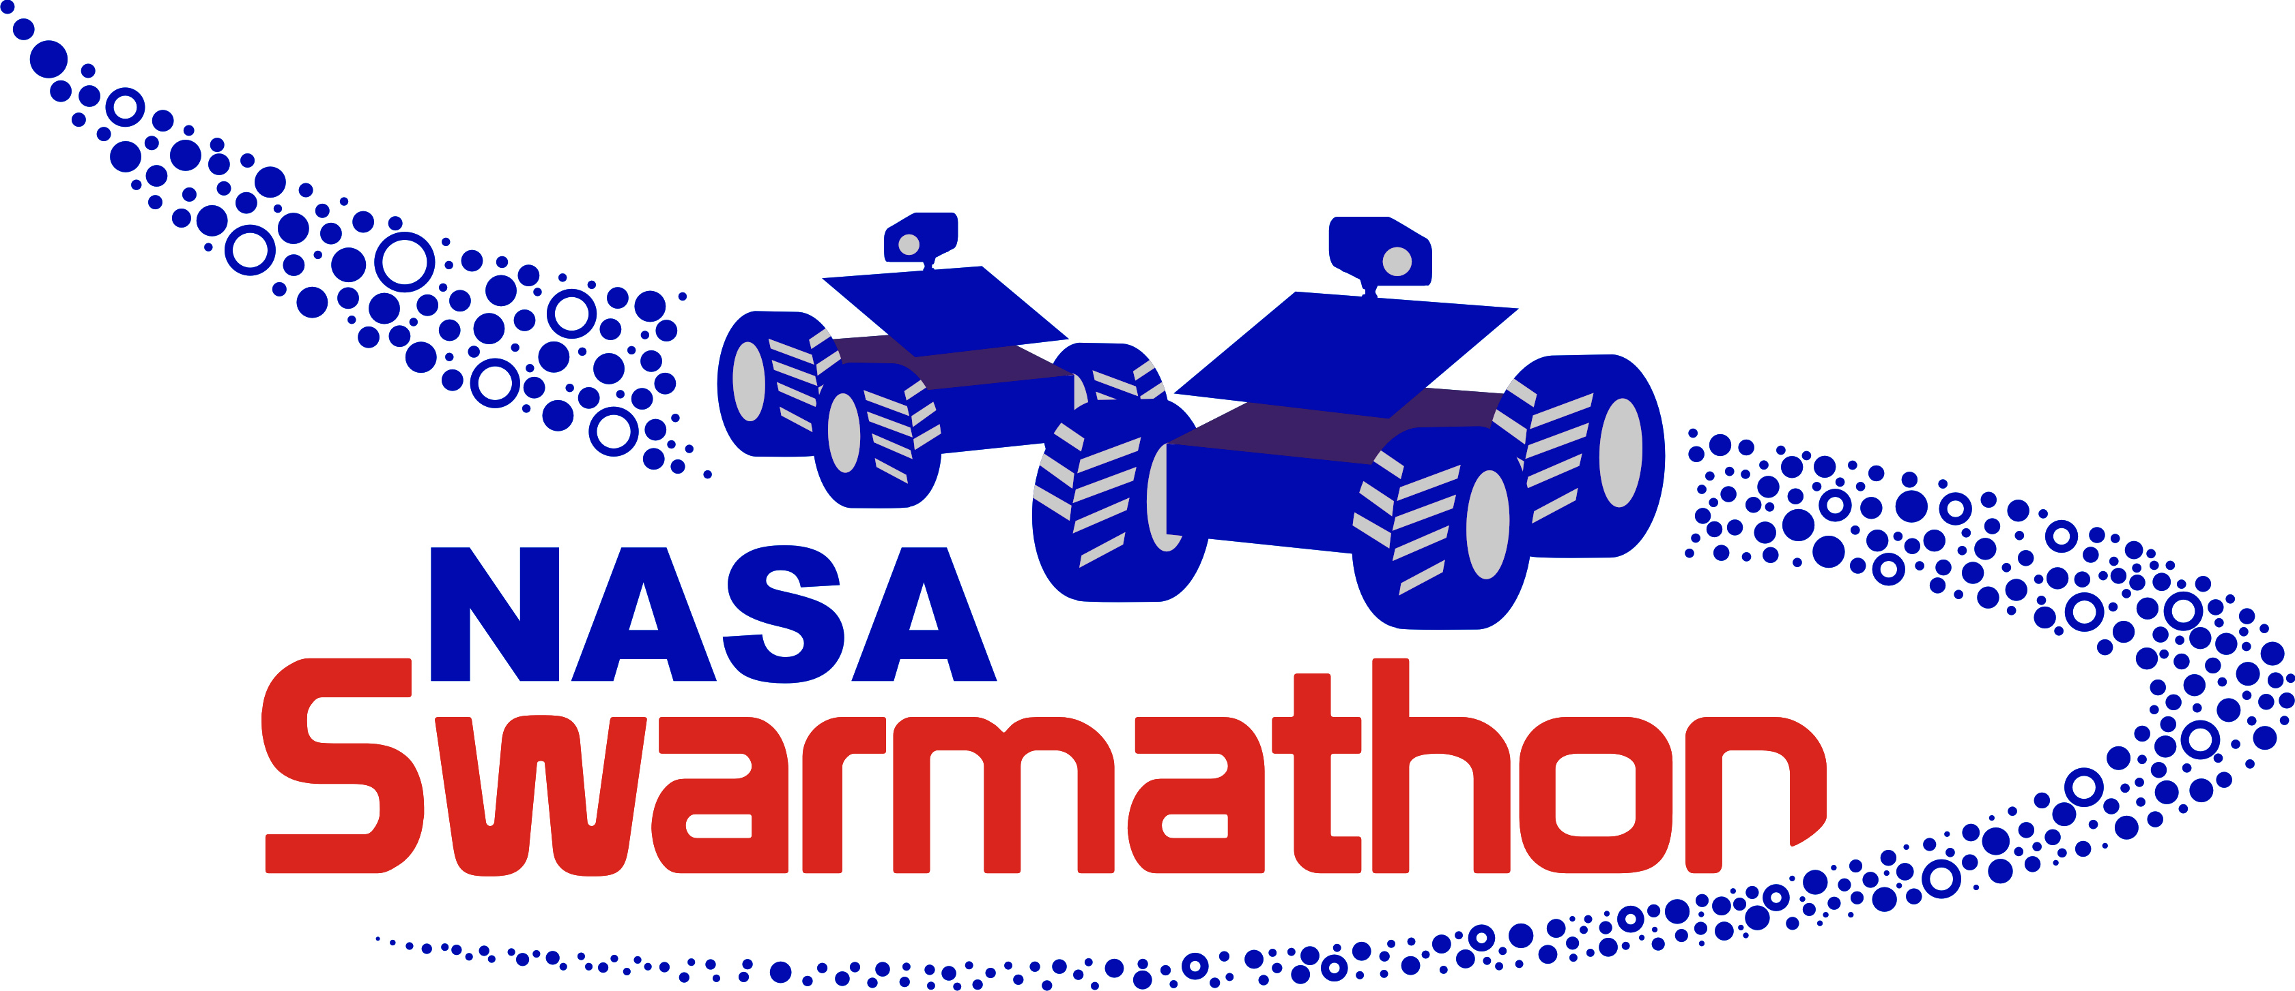GREAT JOB! You completed SWARMATHON 4.

BUG REPORT? FEATURE REQUEST?

email elizabeth@cs.unm.edu with the subject SW4 report

NEXT UP

SWARMATHON 5: competition